WESTERN HEIGHTS WATER AUTHORITY AGENDA - OCTOBER 13, 2022

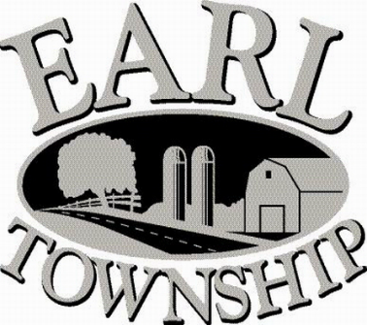
Call to order:

Approve minutes: September 8, 2022

Public Comment:

New Business:
Approve 823 W Main Street connecting to the public water system (failed sampling)

Maher Duessel will no longer be completing audits due to staffing shortage

Approve releasing J&E Grill escrow money
Approve adding to agenda

Operator’s report:

Engineer’s Items:

Solicitor’s Items:

Old Business:

Not to be forgotten:
Capital Asset Maintenance Schedule and Depreciation polices
Review letter of collection for Sheriff Sale

Delinquent accounts: $ 353.69

September Revenue: $ 703.36

Approve disbursements: $32,059.46 Checks #4690 - 4701

Adjourn:

