WESTERN HEIGHTS WATER AUTHORITY AGENDA - NOVEMBER 10, 2022

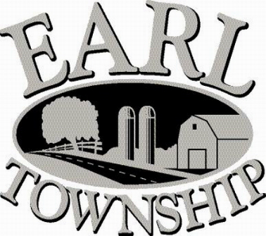
Call to order:

Approve minutes: October 13, 2022

Public Comment:

New Business:
Approve advertising the WHWA meeting dates for the year 2023, which will be held on the second Thursday of each month at 6:00 p.m.
January 12 April 13 July 13 October 12
February 9 May 11 August 10 November 9
March 9 June 8 September 14 December 14

Review proposed 2023 budget

Operator’s report:

Engineer’s Items:

Solicitor’s Items:

Old Business:

Not to be forgotten:
Capital Asset Maintenance Schedule and Depreciation polices
Review letter of collection for Sheriff Sale

Delinquent accounts: $ 5,239.90

October Revenue: $ 26,883.95

Approve disbursements: $6,520.11 Checks #4702 - 4710

Adjourn:

