WESTERN HEIGHTS WATER AUTHORITY AGENDA - DECEMBER 8, 2022

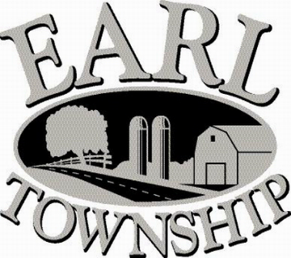
Call to order:

Approve minutes: November 10, 2022

Public Comment:

New Business:
Approve proposed 2023 budget

Operator’s report:
Approve process to start ordering water meters

Engineer’s Items:

Solicitor’s Items:

Old Business:

Not to be forgotten:
Capital Asset Maintenance Schedule and Depreciation polices
Review letter of collection for Sheriff Sale

Delinquent accounts: $ 3,171.88

November Revenue: $ 706.81

Approve disbursements: $5,797.72 Checks #4711 - 4719

Adjourn:

