WESTERN HEIGHTS WATER AUTHORITY AGENDA - SEPTEMBER 8, 2022

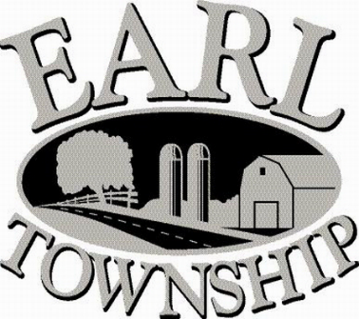
Call to order:

Approve minutes: August 11, 2022

Public Comment:

New Business:
Approve DAJOS Properties LLC, 199 Quality Circle, to take additional 90 days of daily meter readings

Operator’s report:

Engineer’s Items:

Solicitor’s Items:

Old Business:

Not to be forgotten:
823 W Main Street connecting
Capital Asset Maintenance Schedule and Depreciation polices
Review letter of collection for Sheriff Sale

Delinquent accounts: $ 2,548.25

August Revenue: $ 99.77

Approve disbursements: $5,629.97 Checks #4676 - 4689

Adjourn:

