WESTERN HEIGHTS WATER AUTHORITY AGENDA – JANUARY 11, 2024

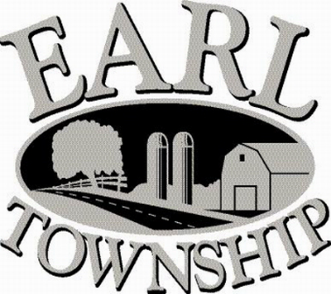
Call to order:

Approve minutes: December 14, 2023

Public Comment:

New Business:
Approve Noah Zimmerman’s new part time schedule

Operator’s report:

Engineer’s Items:

Solicitor’s Items:

Old Business:

Not to be forgotten:

Delinquent accounts: $1,358.22

December Revenue: $1,638.33

Approve disbursements: $4,257.02 Checks #4855 - #4864

Adjourn:

