WESTERN HEIGHTS WATER AUTHORITY AGENDA - JANUARY 12, 2023

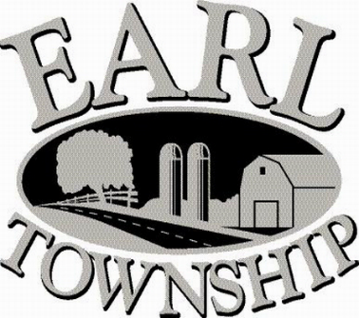
Call to order:

Approve minutes: December 8, 2022

Public Comment:

New Business:
Approve advertising the WHWA meeting dates for the year 2023, which will be held on the second Thursday of each month at 6:00 p.m.
January 12 April 13 July 13 October 12
February 9 May 11 August 10 November 9
March 9 June 8 September 14 December 14

Operator’s report:
Approve $20,000 expenditure for ordering meters & completing the water meter replacement project

Engineer’s Items:

Solicitor’s Items:

Old Business:

Not to be forgotten:
Capital Asset Maintenance Schedule and Depreciation polices
Review letter of collection for Sheriff Sale

Delinquent accounts: $ 85.42

December Revenue: $23,458.78

Approve disbursements: $ 9,715.60 Checks #4721 - 4730

Adjourn:

