WESTERN HEIGHTS WATER AUTHORITY AGENDA – NOVEMBER 9, 2023

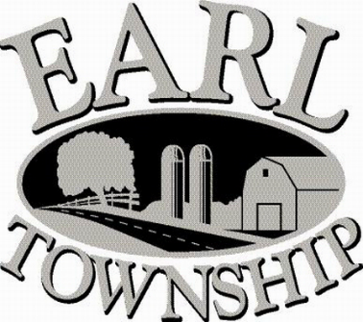
Call to order:

Approve minutes: October 12, 2023

Public Comment:

New Business:
Approve advertising the WHWA meeting dates for 2024, which will be held on the second Thursday of each month at 6:00 p.m.
January 11 April 11 July 11 October 10
February 8 May 9 August 8 November 14
March 14 June 13 September 12 December 12

Review 2024 Draft Budget

Operator’s report:

Engineer’s Items:

Solicitor’s Items:

Old Business:

Not to be forgotten:

Delinquent accounts: $5,686.12

October Revenue: $29,243.85

Approve disbursements: $7,042.88 Checks #4831 - 4841

Adjourn:

