WESTERN HEIGHTS WATER AUTHORITY AGENDA – DECEMBER 14, 2023

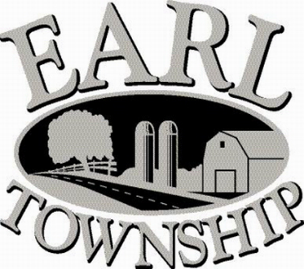
Call to order:

Approve minutes: November 9, 2023

Public Comment:

New Business:
Review Dajos Properties LLC, 199 Quality Circle, 90 days of daily meter readings

Approve 2024 Budget

Executive Session regarding Employee matters

Operator’s report:

Engineer’s Items:

Solicitor’s Items:

Old Business:

Not to be forgotten:

Delinquent accounts: $1,693.67

November Revenue: $1,001.08

Approve disbursements: $9,279.56 Checks #4842 - #4854

Adjourn:

