WESTERN HEIGHTS WATER AUTHORITY AGENDA - FEBRUARY 9, 2023

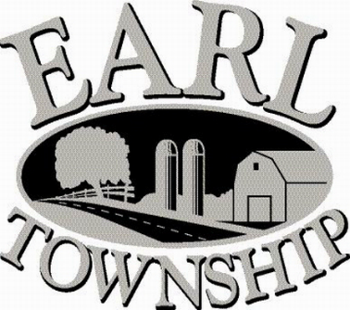
Call to order:

Approve minutes: January 12, 2023

Public Comment:

New Business:
Approve Resolution 2023-01

Approve Spencer’s Employee Leasing Agreement

Operator’s report:

Engineer’s Items:

Solicitor’s Items:

Old Business:

Not to be forgotten:
Capital Asset Maintenance Schedule and Depreciation polices
Review letter of collection for Sheriff Sale

Delinquent accounts: $1,109.74

January Revenue: $ 6,000.00

Approve disbursements: $5,109.02 Checks #4732 - 4741

Adjourn:

