WESTERN HEIGHTS WATER AUTHORITY AGENDA - MARCH 9, 2023

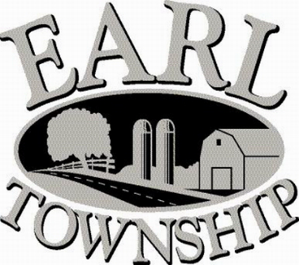
Call to order:

Approve minutes: February 9, 2023

Public Comment:

New Business:
Approve Longley Insurance Agency as insurance broker

Approve Tapping Fee Resolution #2023-01

Operator’s report:

Engineer’s Items:

Solicitor’s Items:

Old Business:

Not to be forgotten:
Capital Asset Maintenance Schedule and Depreciation polices
Review letter of collection for Sheriff Sale

Delinquent accounts: $947.49

February Revenue: $ 63.91

Approve disbursements: $4,787.39 Checks #4742 - 4748

Adjourn:

