WESTERN HEIGHTS WATER AUTHORITY AGENDA - MAY 11, 2023

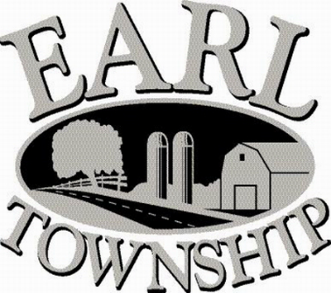
Call to order:

Approve minutes: April 13, 2023

Public Comment:

New Business:
Longley Insurance

Approve assessing additional EDU to DAJOS Properties, 199 Quality Circle, additional 90 days of reading

Executive Session:

Operator’s report:

Engineer’s Items:

Solicitor’s Items:

Old Business:

Not to be forgotten:
Review letter of collection for Sheriff Sale

Delinquent accounts: $2,685.02

April Revenue: $ 553.79

Approve disbursements: $5,011.62 Checks #4763 - 4769

Adjourn:

