WESTERN HEIGHTS WATER AUTHORITY AGENDA - JUNE 8, 2023

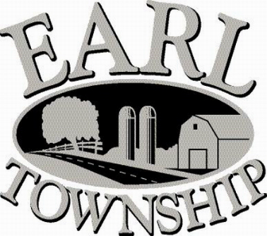
Call to order:

Approve minutes: May 11, 2023

Public Comment:

New Business:
Linford Zimmerman, DAJOS Properties, 199 Quality Circle, discuss leak that discovered

Operator’s report:

Engineer’s Items:

Solicitor’s Items:

Old Business:

Not to be forgotten:

Delinquent accounts: $774.24

May Revenue: $ 93.94

Approve disbursements: $5,597.33 Checks #4770 - 4777

Adjourn:

