WESTERN HEIGHTS WATER AUTHORITY AGENDA – JULY 13, 2023

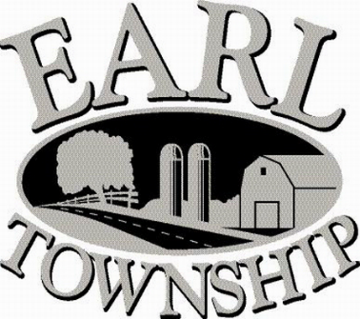
Call to order:

Approve minutes: June 8, 2023

Public Comment:

New Business:

Operator’s report:

Engineer’s Items:

Solicitor’s Items:

Old Business:

Not to be forgotten:

Delinquent accounts: $4,889.40

June Revenue: $27,901.60

Approve disbursements: $8,417.23 Checks #4778 - 4791

Adjourn:

