WESTERN HEIGHTS WATER AUTHORITY AGENDA – AUGUST 10, 2023

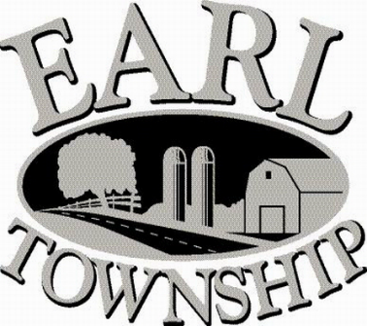
Call to order:

Approve minutes: July 13, 2023

Public Comment:

New Business:

Operator’s report:

Engineer’s Items:

Solicitor’s Items:

Old Business:

Not to be forgotten:

Delinquent accounts: $6,848.94

July Revenue: $843.29

Approve disbursements: $10,072.74 Checks #4792 - 4805

Adjourn:

