WESTERN HEIGHTS WATER AUTHORITY AGENDA – SEPTEMBER 14, 2023

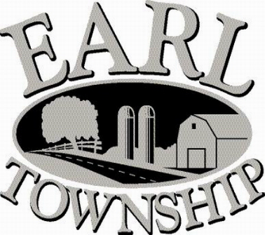
Call to order:

Approve minutes: August 10, 2023

Public Comment:

New Business:
Approve Spencer Beck’s wage increase of $2.17 per hour due to receiving his sewer license.

Operator’s report:

Engineer’s Items:

Solicitor’s Items:

Old Business:

Not to be forgotten:

Delinquent accounts: $1,082.32

August Revenue: $879.81

Approve disbursements: $ 7,268.69 Checks #4806 - 4818

Adjourn:

