WESTERN HEIGHTS WATER AUTHORITY AGENDA – APRIL 11, 2024

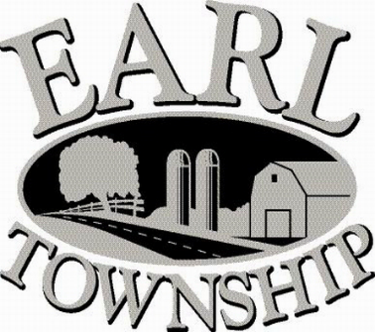
Call to order:

Approve minutes: March 14, 2024

Public Comment:

New Business:
Executive session regarding employee matters

Operator’s report:

Engineer’s Items:

Solicitor’s Items:

Old Business:

Not to be forgotten:

Delinquent accounts: $ 309.72

March Revenue: $ 10,958.36

Approve disbursements: $ 11,919.55 Checks #4887 - #4901

Adjourn:

